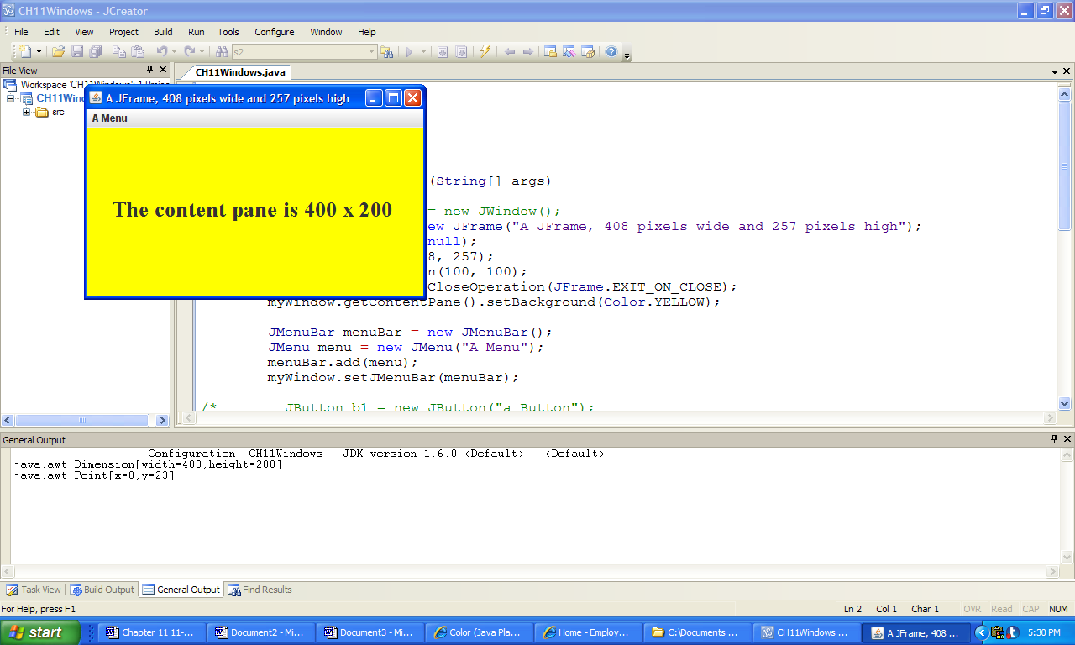 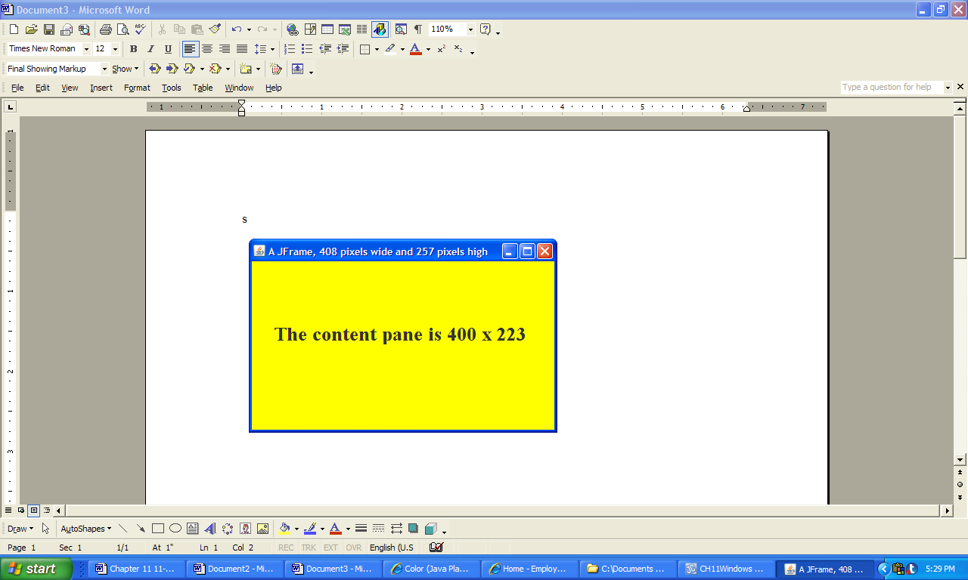

x

y

x

y

**a) b)**

**Figure 11.7 Two JFrame windows 408 pixels wide and 257 pixels high.**